

Laptop Request Catalog Item using ServiceNow

*Team ID:*

NM2025TMID20163

Team Members: Team Leader: SATHYA N

Team Member 1:

LENIN A

Category:

ServiceNow

System

Administrator

Problem

Statement:

Employees

in

the

organization

need

a

quick

and

efficient way to request laptops for work. The current

process is manual, prone to delays, and lacks dynamic

form

behavior

to

guide

users

or

ensure

accurate

data

collection.

This

often

results

in

incomplete

requests,

miscommunication, and inefficiencies.

Objective:

To design and implement a Service Catalog item in ServiceNow that enables employees to easily request laptops with:

Dynamic fields based on user selections.

Clear instructions for accurate data entry.

A reset option for the form when needed.

End-to-end tracking of all changes for governance and deployment.

Skills Required:

ServiceNow Catalog Item Development

ServiceNow Client Scripts & UI Policies

Flow Designer / Workflow Configuration

Data Governance & Change Management

Project Description:

This project aims to build a Laptop Request Service Catalog Item on the ServiceNow platform. The system will allow users to:

Submit structured laptop requests through a guided form.

Experience dynamic field behavior

(show/hide/require fields based on selections).

Reset the request form when necessary. Trigger automated approvals and fulfillment workflows.

Ensure all changes and deployments are tracked for governance.

Generate reports on requests, approvals, and fulfillment metrics for better IT asset management.

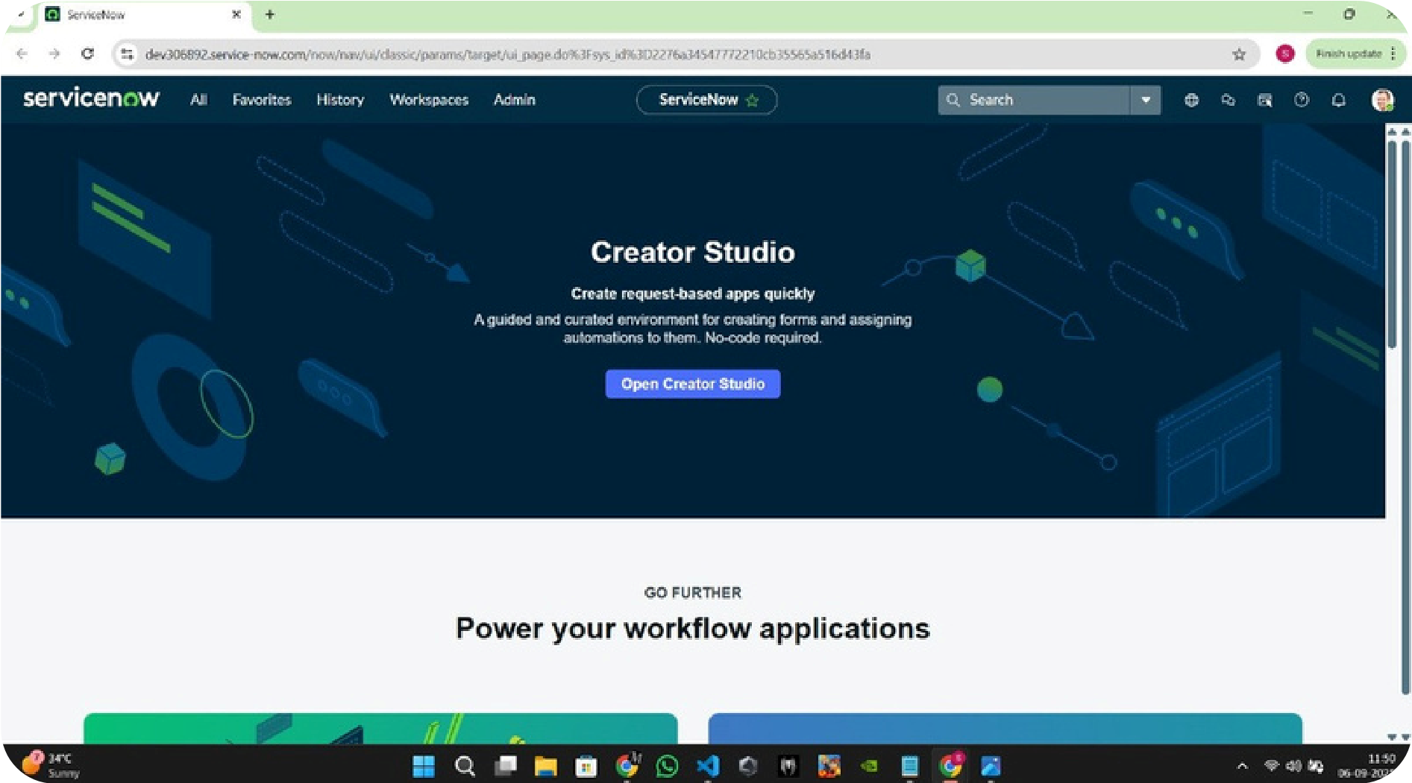

Milestone 1 :

Setting up ServiceNow Instance

Activit

y 1:

[C](https://developer.servicenow.com/)

reate and Access Instance

1.

Open

ServiceNow Developer Site

[.](https://developer.servicenow.com/)

2.

Sign up for a developer account and log in.

3.

Navigate to Personal Developer Instance.

4.

Click Request Instance and fill the required details.

5.

Submit the request.

6.

Once approved, check your email for instance details.

7.

Log in using the provided credentials.

8.

Verify that you can successfully access and navigate

the instance.

TASK INITIATION

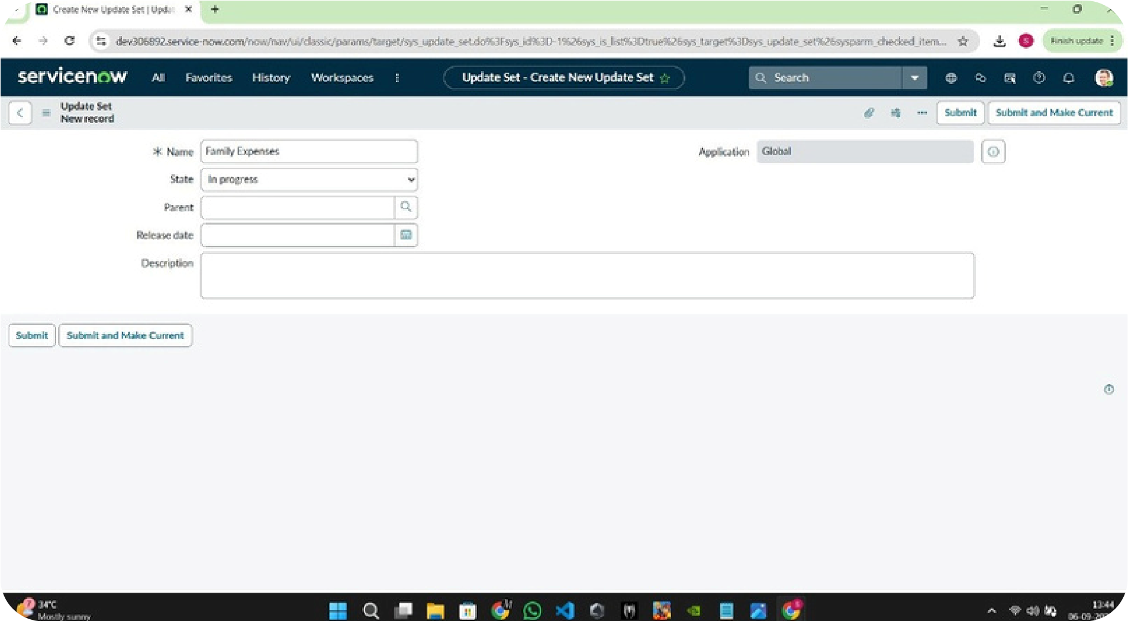

1

.

Open service now.

2

.

Click on All >> search for update sets

3

.

Select local update sets under system update sets

4

.

Click on new

5

.

Fill the following details to create a update set as: “Laptop Request”

6

.

Click on submit and make current

7

.

By clicking on the button it activates the update set .

Milestone 2 :

Create Local Update Set

Activity 1:

Create Update Set

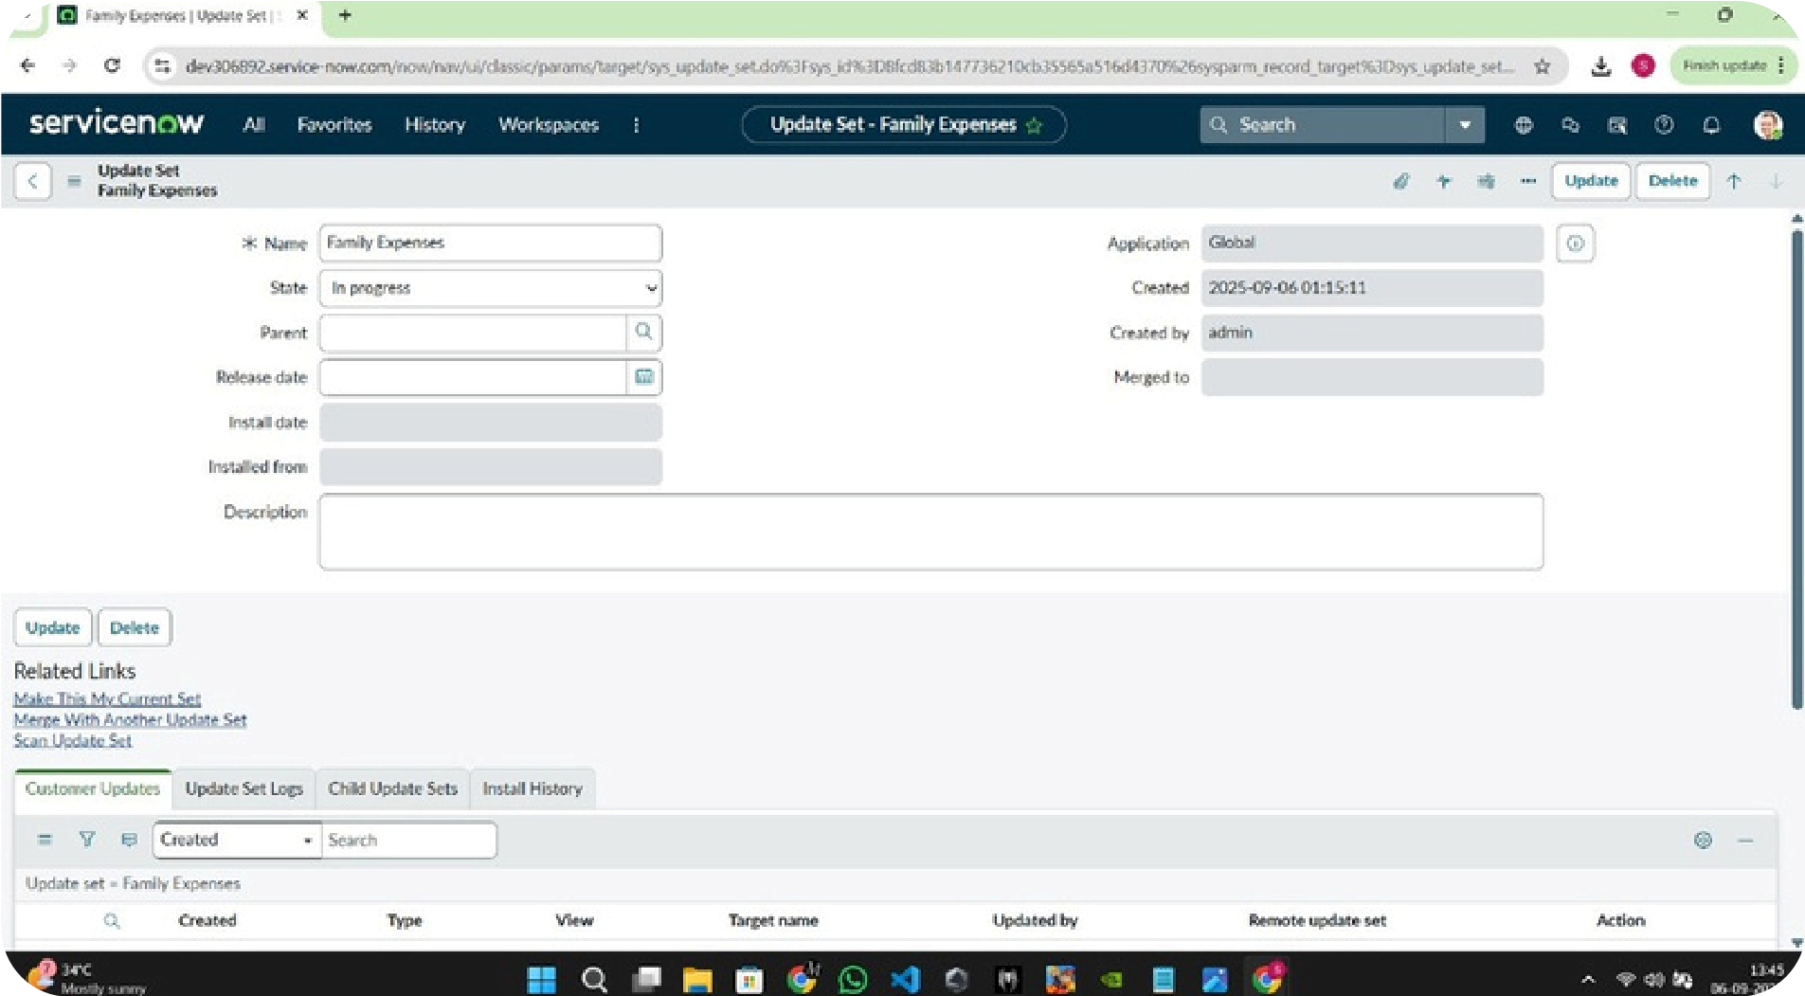

1

.

Open service now.

2

.

Click on All >> service catalog

3

.

Select maintain items under catalog definitions

4

.

Click on New.

5

.

Fill the following details to create a new catalog item

6

.

Name: Laptop Request

7

.

Catalog: service Catalog

8

.

Category: Hardware

9

.

Short Description: Use this item to request a new laptop

10

.

Click on ‘SAVE’

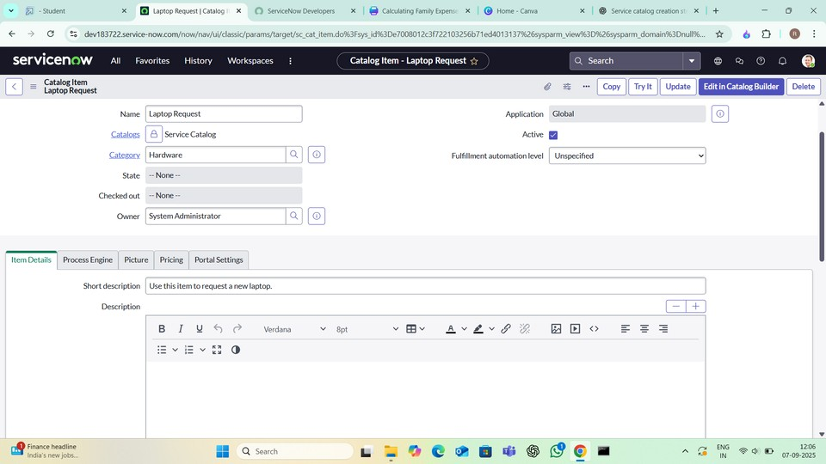

Milestone 3:

Creation of Service Catalog Item

Activity 1:

Create Service Catalog Item

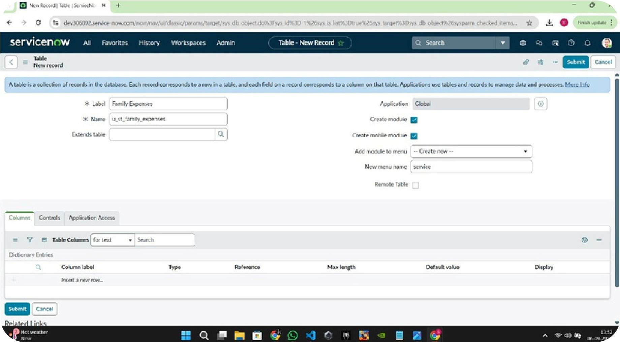

Step1:

After saving the catalog item form scroll down and click on

variable(related list)

Click on new and enter the details as below

1

. Variable 1:Laptop Model

Type: Single line text

Name: laptop_model

Order:100

Click on submit

Again click on new and add Remaining variables in the above process

2

. Variable 2:Justification

Type: Multi line text

Name: justification

Order:200

3

. Variable 3:Additional Accessories

Type: Checkbox

Name: additional_accessories

Order:300

4

. Variable 4: Accessories Details

Type: Multi line text

Name:accessories_details

Order:400

Milestone 3: Add variables

Activity 2: Add variables

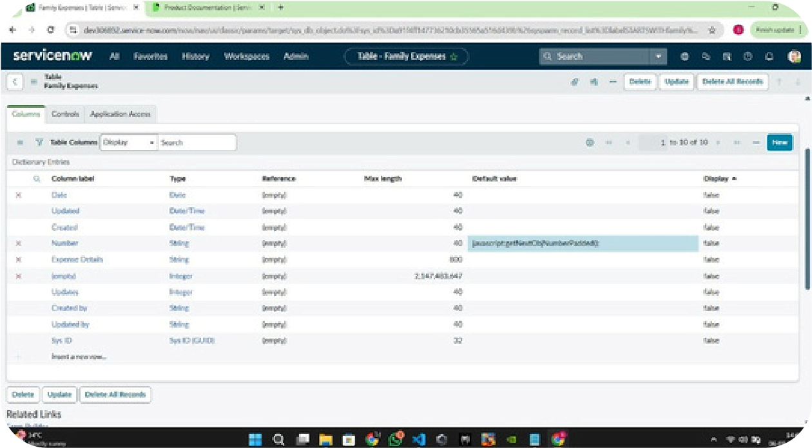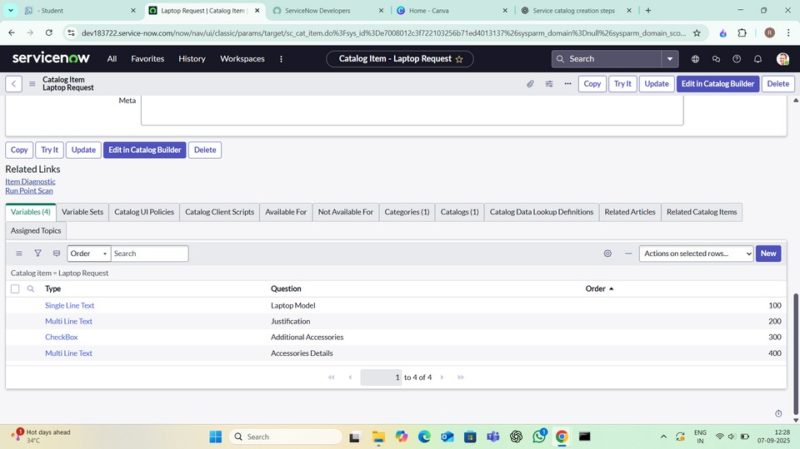

Step2:

After adding above variable which are added to newly created catalog

item

Then save the catalog item form

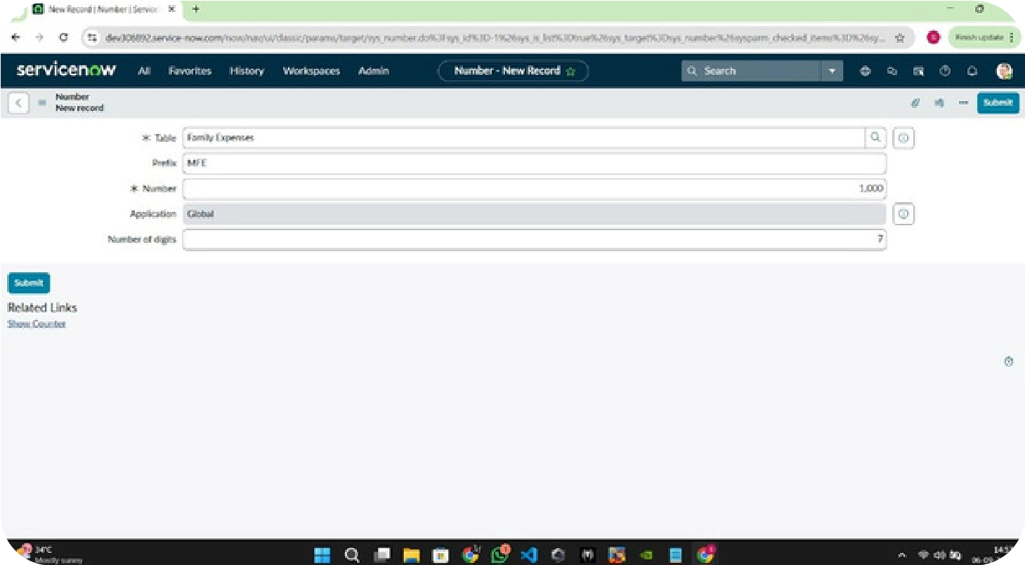

1

.

Click on all>> search for service catalog

2

.

Select maintain item under catalog definition

3

.

Search for ‘laptop request’ which is created before

4

.

Select ‘laptop request’ and scroll down click on “Catalog Ui policies”

5

.

In the catalog ui policies related list tab click on new

6

.

Give short description as: show accessories details

7

.

Set the Catalog Condition in the related list tab ‘when to apply’

[

field: additional_ accessories, operator: is, value: true

]

8

.Click on save.(do not click on submit

)

9

.Scroll down and select ‘catalog ui action’

10

.Then click on new button

11

.Select variable name as: accessories_details

Order:100

Mandatory: True

Visible : True

12

.Click on save and again click save button of the catalog ui policy

form.

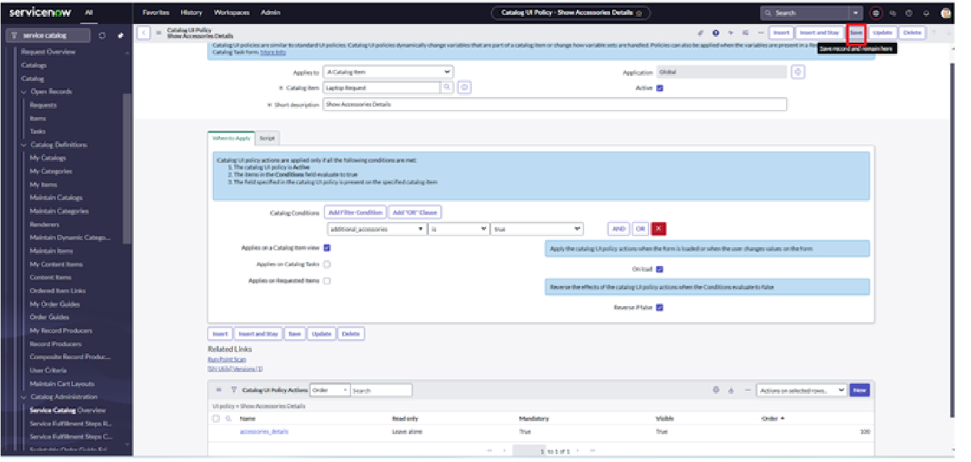

Milestone 4 : creation UI Policy

Activity 1: Create Catalog Ui policies

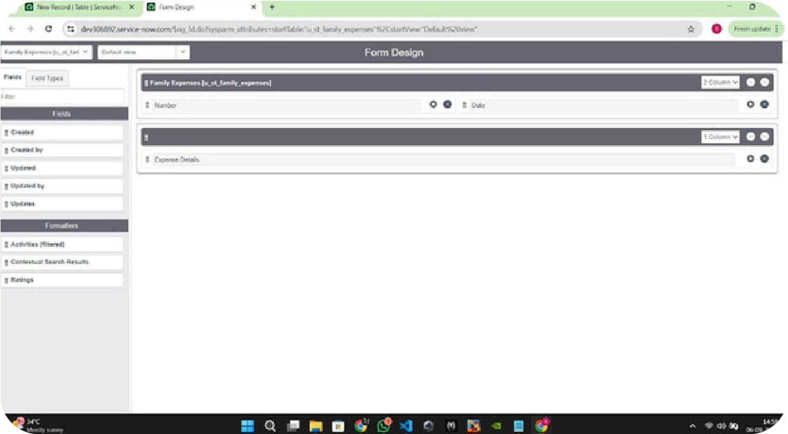

1

.

Open service now.

2

.

Click on All >> search for ui action

3

.

Select ui actions under system definition

4

.

Click on new

5

.

Fill the following details to create ui action

Table: shopping cart(sc_cart)

Order:100

Action name: Reset form

Client : checked

Script:

function resetForm() {

g_form.clearForm(); // Clears all fields in the form

alert("The form has been reset.");

}

Click on save

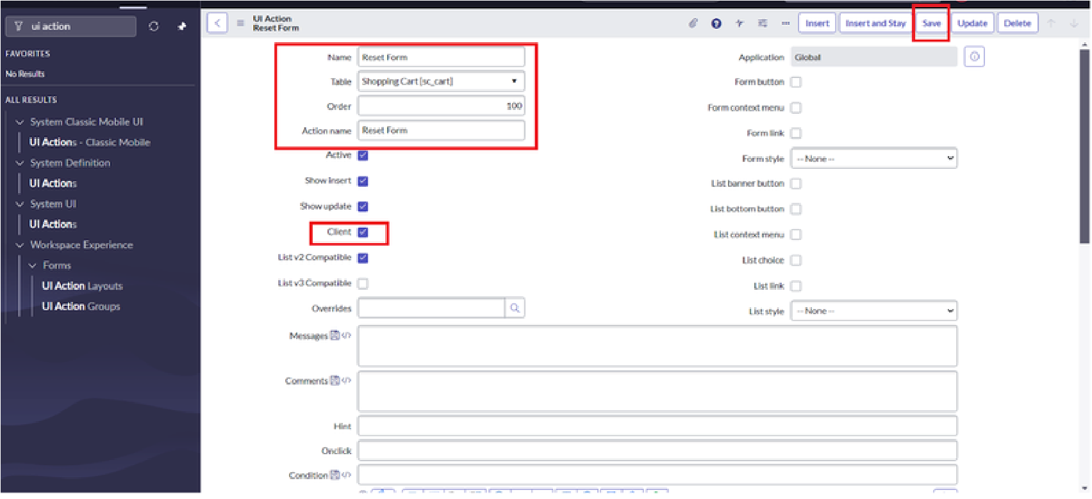

Milestone 5:

UI ACTIONS

Activity 5: Create ui action

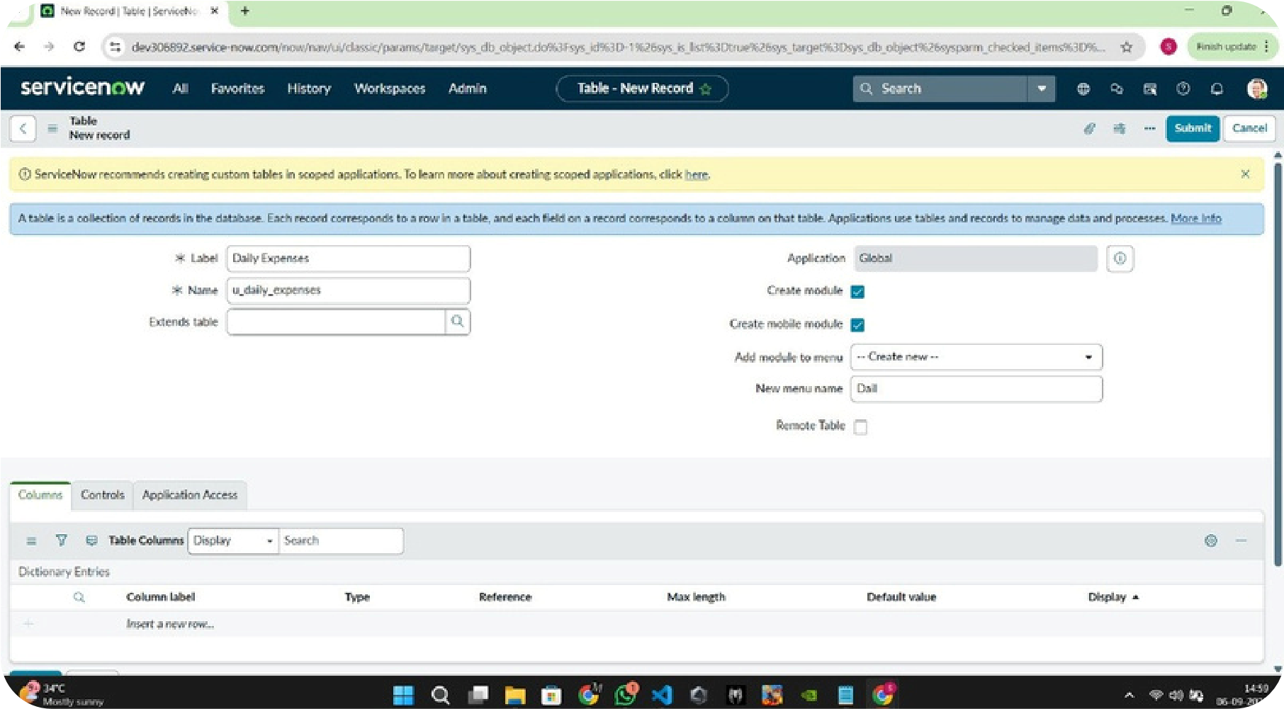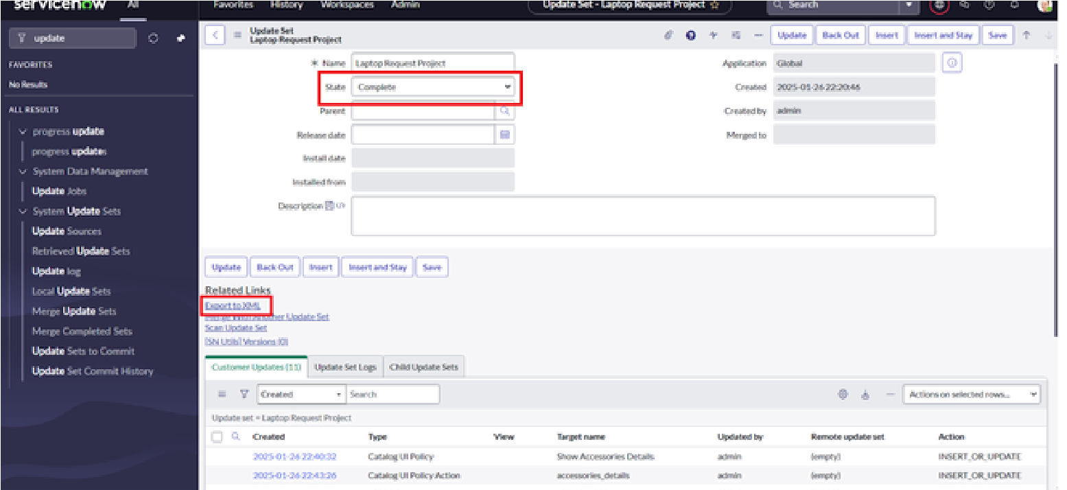

1

.

Click on All >> search for update sets

2

.

Select local update set

3

.

Select created update set i.e. ‘Laptop Request Project’

4

.

Set the state to ‘Complete’

5

.

In the related list Update tab, updates are visible which we perform

under this update set.

6

.

Click on export to XML ,it download one file

Milestone 8: Export Update set

Activity 1: Exporting changes to another instance

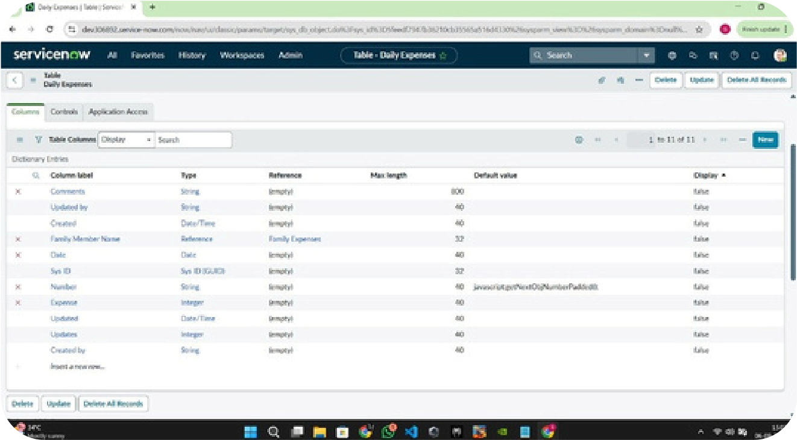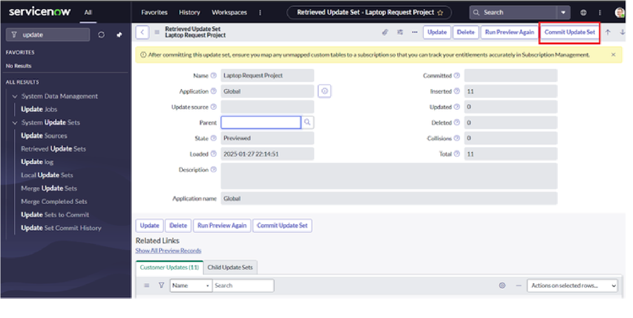

1

.

Open another instance in incognito window

2

.

Login with credentials

3

.

Click on all>> search for update sets

4

.

Select “Retrieved update set” under system update set

5

.

It open retrieved update set list and scroll down

6

.

Click on Import update set from XML

7

.

Upload the downloaded file in XML file

8

.

Click on Upload and it gets uploaded.

9

.

Open retrieved update set ‘laptop request project’

10

.

Click on preview update set

11

.

And click on commit update set

12

.

And also see the related tab updates

13

.

After commiting update set in this instance we get all

updates which are done in the previous instance

Milestone 6 : Login to another Instance

Activity 1: Retrieving the update set

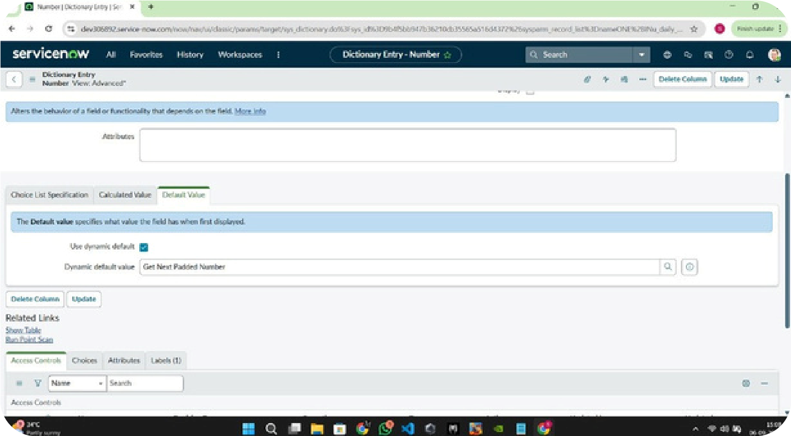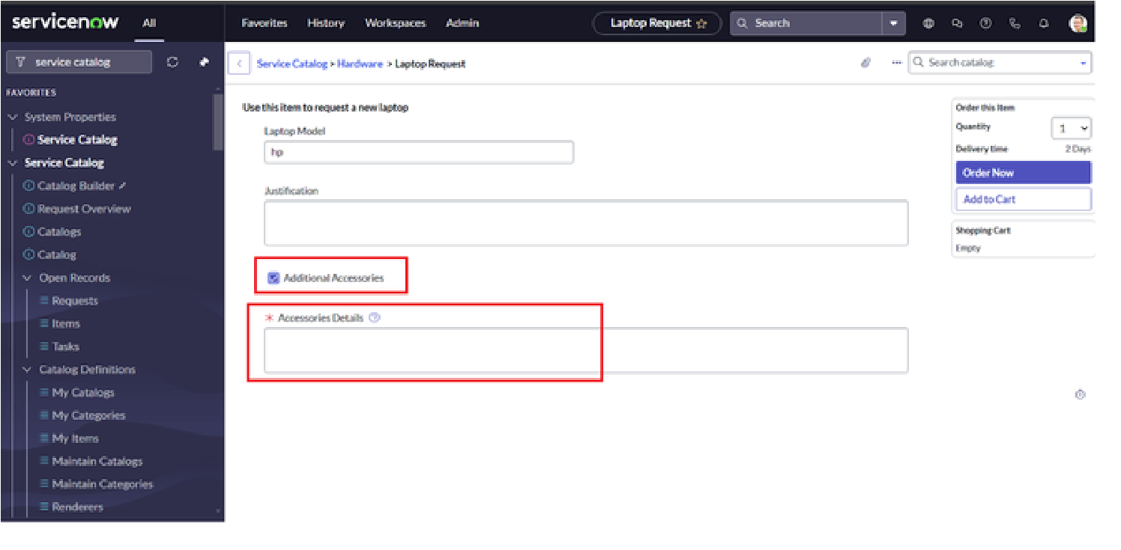

1

.

Search for service catalog in application navigator in target

instance

2

.

Select catalog under service catalog

3

.

Select hardware category and search for ‘laptop request’ item

4

.

Select laptop request item and open it

5

.

It shows three variables only

6

.

As per our scenario, when we click on additional accessories

checkbox then accessories details fields is visible and that

should be mandatory

7

.

Now see the results,it fulfills our requirements.

Milestone 7 : Testing

Acivity 3: Test Catalog Item



Conclusion:

The

Laptop

Request

Catalog

Item

project

successfully

streamlines the process of requesting laptops within the

organization

by

leveraging

ServiceNow's

Service

Catalog

capabilities.

Through

the

implementation

of

a

dynamic

catalog

item,

the

project

ensures

that

users

have

an

intuitive

and

user-friendly

interface,

reducing

errors

and

improving

efficiency.This

project

demonstrates how ServiceNow can be used to replace

manual,

error-prone

processes

with

automated,

efficient, and user-centric solutions. It not only improves

service delivery but also enhances employee satisfaction

by

providing

a

modern

and

streamlined

request

experience.